Solar system scale investigation

You will be creating 2 scale models / diagrams comparing the distance from the sun and the diameters of 2 different celestial bodies. One of the celestial bodies must be from the area of our solar system that exists between the sun and the asteroid belt and the other must exist between the asteroid belt and the Kuiper belt.

SSSI- scale drawing calculations.

Fill in the top row of the tables below from the information you researched above to determine the scale needed to create your diagrams. If you need help, [use this link](https://docs.google.com/presentation/d/1DeDmnq__y8tNutxchMlgFpSK2gMkM52cyb9v6RlGWuM/edit?usp=sharing) for the instructions for these tables.

|  | Celestial body #1 | Celestial body #2 | Celestial body #3 (optional) |
| --- | --- | --- | --- |
| Name: | SUN | Earth | Pluto |
| Actual diameter (km) | 1392700 km | 12742 km | 2776 km |
| Divided by 20 | 69635 | 637.1 | 138.8 |
| Scale  1 cm= ___ km | 1cm = 70000 | 1cm = 70000 | 1cm = 70000 |
| Diameter for diagram | 1392700/ 70000 =19.6 cm | 12742/ 70000 =  0.18 = 0.2 cm | 2776/ 70000 = 0.039= 0.1 cm |

|  | Celestial body #1 | Celestial body #2 | Celestial body #3 (optional) |
| --- | --- | --- | --- |
| Name: | Earth | Pluto |  |
| Actual distance from sun (km) | 150000000 km | 5,900,000,000 km |  |
| Divided by 25 | 6,000,000 | 236,000,000 |  |
| Scale  1 cm= ___ km | 1 cm = 250,000,000 | 1 cm = 250,000,000 |  |
| Distance for diagram | 150,000,000/ 250,000,000 = 0.6 cm | 5,900,000,000/ 250,000,000= 23.6 cm |  |

**PART 2: SCALE MODELS**

**Instructions:** In the space below, create a model of both celestial bodies that is drawn to proper **scale comparing the DISTANCE from the sun** Insert a picture of your model below

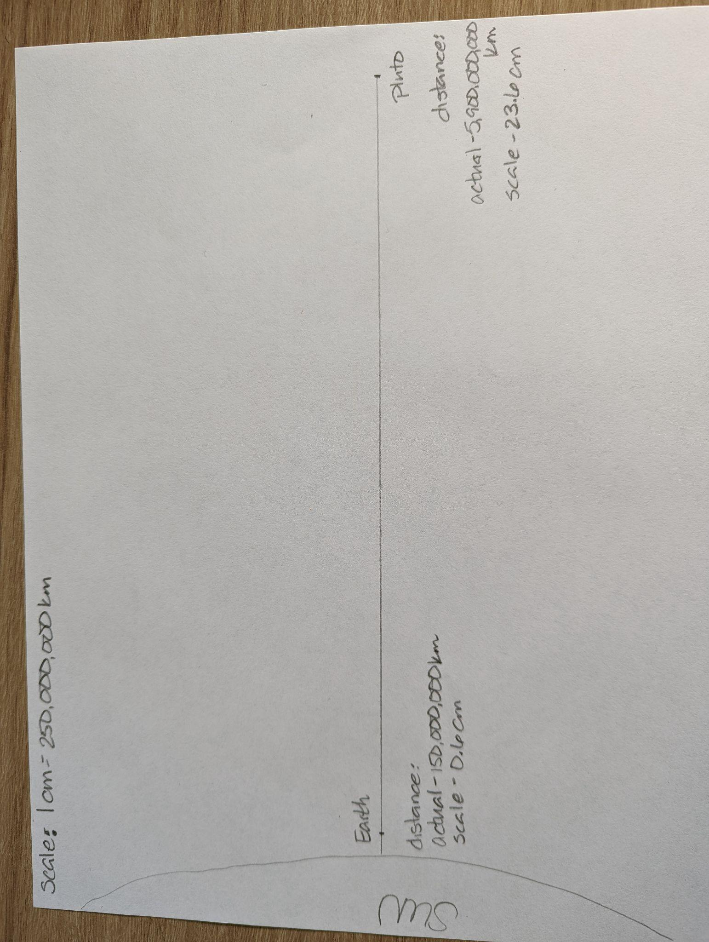

**Instructions:** In the space below, create a model of both celestial bodies that is drawn to proper **scale comparing the DIAMETERS of the celestial bodies** Insert a picture of your model below

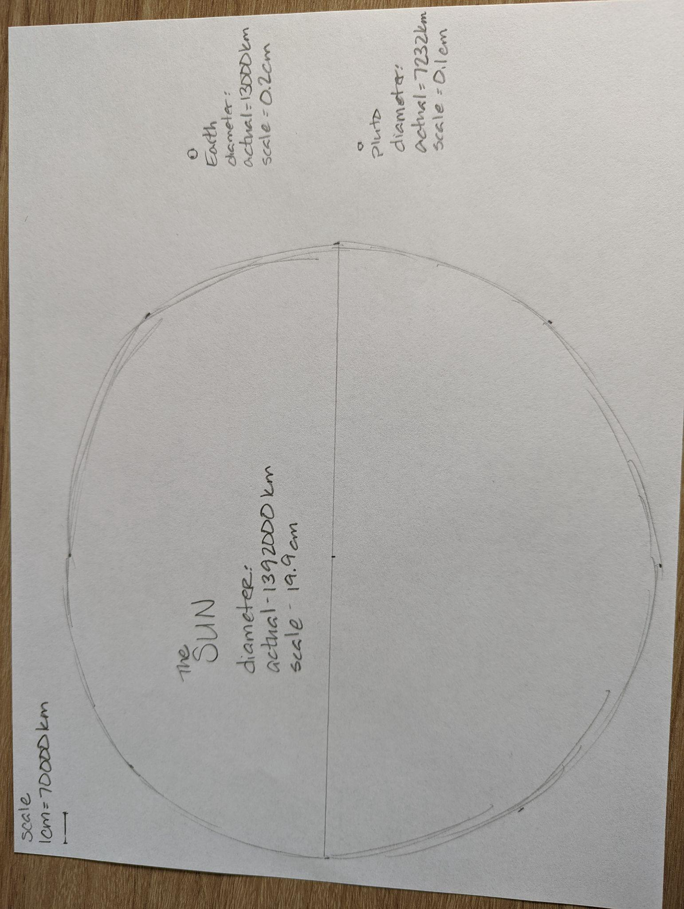

Part 3: Analysis

Use numerical values (such as the diameter, mass and distance of the planet or moons you are focusing on) to analyze and interpret data about scale properties of objects in the solar system.

Use the terms **gravity, mass, weight** to explain why an object has different weights on different planets or moons

The three planets or moons I researched are the sun, Earth and Pluto. The inner planet or moon I chose was Earth. The distance from the sun is 150,000,000 km. The diameter of Earth is 13,000 km. The mass of this planet is 5,900,000,000,000,000,000,000,000 Kg. The outer planet or moon I chose was Pluto. The distance from the sun is 5,900,000,000 km. The diameter of Pluto is 7232 km. The mass of this planet is 13,000,000,000,000,000,000,000 Kg. The other planet or moon I chose was ___________. The distance from the sun is______________ km. The diameter of __________ is ___________ km. When I compare them to each other, I notice that Earth is almost double the diameter of Pluto. I also noticed that Pluto is farther from the sun by 5,750,000,000 km. Also, the mass of Earth is larger thanPluto by almost 6000 Kg. I was surprised by how much bigger the sun was to Earth and Pluto when I compared them on my diagram.

The distance to the outer edge of our solar system is approximately 7,400,000,000 km. My first planet or moon Earth is approximately 1/64th of the distance to this point and my second planet or moon Pluto is approximately 99% as far. My inner planet orbits the sun in 365 ¼ Earth days. My outer planet orbits the sun in 248 Earth years. My third planet or moon orbits the sun in _________________________ Earth (days/ years) When I compare their orbital speeds I noticed Earth orbits the sun much faster than Pluto. Overall I noticed that Earth is bigger in both size and mass than Pluto, that Pluto orbits the sun much slower than Earth and that Pluto is much farther away from the sun than Earth.

My Fiat 500e weighs 1365 Kg on Earth. On Pluto it would weigh 91.4 Kg, and on ________________ it would weigh _______________. Mass is (put the definition from your notes here). An object’s mass influences the weight of the object on Pluto and ___________ compared to Earth because __________________ _______________________________________________________________________.

Gravity is (put the definition from your notes here). The 2 factors that influence gravity are ________________ and ____________. Gravity influences an object’s weight on Pluto and _____________________ because _______________________ _______________. The mass of Earth and Pluto influence the weight of my object because ________________________. Together gravity & mass influence an object’s weight on different planets or moons. This occurs because __________________________________________________________.

Rubric

|  | **4** | **3** | 2 | 1 |
| --- | --- | --- | --- | --- |
| **MS-ESS1**  **Earth’s Place in the Universe**  Analyze and interpret data to determine scale properties of objects in the solar system. | * All components of a 3 are complete * AND I have gone above and beyond the expectations of a 3 by...   + I compared 3 planets or moons   OR   * + [insert what you have done to go above and beyond the expectations here]   I included a third planet in my diameter research and drawing. | Part 1: research   * Selected two planets or moons * Identified the inner planet/moon investigated * Identified the outer planet/moon investigated * Accurately lists the following information for BOTH celestial bodies:   + Name   + Diameter   + Mass   + Distance from Sun   + Period of rotation   + Orbital period   + Number of natural satellites   + Significant information about its structure   + Identifies at least TWO similarities between the celestial bodies   + Identifies at least TWO differences between the celestial bodies * Accurately defines weight * Accurately identifies the weight of an object on: * Earth * planet/moon #1 * planet/moon #2   All sources used are cited | Part 1: research  Needs to select one inner planet OR one outer planet/ moon to focus on  Needs to accurately list the following information for one or both of the celestial bodies:   * + Name   + Diameter   + Mass   + Distance from Sun   + Orbital period   + Number of natural satellites   + Significant information about its structure   + Needs to identify more similarities and/or differences between the planets or moons   + Needs to define weight   + Needs to find the weight of an object on the planet/moon researched   Needs to cite sources used | Part 1: research   * Needs to identify and research 2 planets or moons, 1 from the inner and 1 from the outer regions of our solar system * Needs to complete the comparison section * Needs to complete the section on gravity |
| Develop and use a model to determine scale properties of objects in the solar system | I included 3 planets or moons in my diagram for diameter and distance from the sun. | Part 2: models/ diagrams  Includes an accurate scale model comparing the distance from the sun of the two planets or moons  Includes a key for the scale model that shows the scale being used for the distances  Includes an accurate scale model comparing the diameters of the two planets or moons  Includes a key for the scale model that shows the scale being used for diameter | Part 2: models/ diagrams  Needs to include an accurate scale model of the two planets or moons for the distance from the sun  Needs to include a key for the model that shows the scale used for the distance from the sun  Needs to include an accurate scale model of the two planets or moons for the diameter  Needs to include a key for the model that shows the scale used for the diameter of the planets or moons | Part 2: models/ diagrams   * Needs to create a diagram or model showing the scale comparison of diameter of the planets or moons |
| Analyze and interpret data to determine scale properties of objects in the solar system  and describe the role of gravity in the interactions between objects in the solar system. | Included all 3 planets or moons in the analysis and interpretation of the scale properties | Part 3: analysis  Accurately use numerical values to analyze and interpret data about scale properties of objects in the solar system.   * Accurately compares the diameters of the planets or moons researched in part 1. * Accurately compares the distances from the sun of the planets or moons researched in part 1.   Compares the weight of an object on the planet/moon researched  Accurately explains WHY weight varies between different planets or moons by utilizing:   * + Numerical values (mass of planets or moons) AND mass of object with units   + The accurate definition and use of the term **gravity**   + The accurate definition and use of the term **mass**   + The accurate definition and use of the term **weight**   Accurately explains the relationship between the planet or moon's mass related to the mass of the object and how it is affecting the weight | Part 3: analysis  Needs to accurately use numerical values to analyze and interpret data about scale properties of objects in the solar system.   * Needs to accurately compare the diameters of the planets or moons researched in part 1. * Needs to accurately compare the distances from the sun of the planets or moons researched in part 1.   Needs to compares the weight of an object on the planet/moon researched  Needs an accurate explanation of WHY weight varies between different planets or moons:   * + Needs numerical values for (mass of planets or moons) AND mass of object OR unit   + Needs to accurately define and use the term **gravity**   + Needs to accurately define and use the term **mass**   + Needs to accurately define and use the term **weight**   Needs to accurately explain the relationship between the planet or moon's mass related to the mass of the object OR how it is affecting the weight | Part 3: analysis   * Needs to compare the diameters and distances from the sun between different planets or moons * Needs to explain WHY weight varies between different planets or moons * Needs to include numeric data   Needs to accurately explain the relationship between the planet or moon's mass related to the mass of the object and how it is affecting the weight |